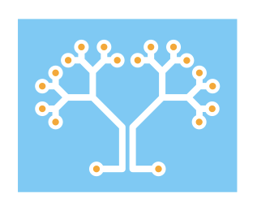

The Enterprise Neurosystem

RFI Response:

Update of the National Artificial Intelligence Research and Development Strategic Plan

Introduction

The Enterprise Neurosystem is an open source community of Fortune 500 companies, enterprise technology vendors, and academia. It is ultimately designed to address the fundamental challenges of large-scale AI infrastructure to protect our global ecosphere. The founding academic institutions include Stanford SLAC, Harvard Analytics and UC Berkeley Data-X. Participating firms include America Movil, Equinix, Fiducia | AI, IBM Research, Intel, Kove, PerceptiLabs, Verizon Media/Yahoo!, Red Hat, Reliance Jio and others.

The Challenge

Climate change, energy security, agricultural challenges, political unrest, and mass migration pose immediate threats to global stability and the planet’s health as a whole. The exponential growth of technology provides us with the means to address these challenges, but only if we, as a nation, can build an enabling infrastructure to leverage that technology effectively. The National Artificial Intelligence Research and Development Strategic Plan guides our opportunities to unlock innovations that the culmination of emerging heterogeneous systems will merge to reveal cross-domain patterns in data, algorithms, technology, and discoveries that lead to robust solutions for the longevity of our public, private, and commercial way of life.

The Enterprise Neurosystem community sees the tailoring of the OSTP Strategic Plan as a means to more optimally guide the construction of a wide-ranging AI infrastructure, one with broad public and private buy in, that will enable rapid application of US creativity to solve the challenges that lie ahead – identifying and circumventing environmental threats, providing advanced insight into human migration, integrating climate-adaptive agriculture from local to global scales, dynamically accommodating supply chain and energy grid disruptions, and ultimately advancing secure fusion and nuclear energy in a heterogeneous supply producer ecosystem. The mission here is to promote sustainably accelerated advancement that is consistent with our hypothesis that diversity and heterogeneity in technology as in thought will yield resilient solutions in a changing world, a hypothesis support by US history and by Nature’s own demonstration of using diversity as a tool for bending but never breaking under stress.

Planetary scale objectives begin with smaller developmental steps at the intersection of the scientific community and the Fortune 500 enterprise market. For lasting and meaningful change, government sponsored scientific advancement must quickly integrate into the commercial market and there grow legs of its own to live and breathe beyond the initial research seed funding. By nurturing a mid-tier environment for the national AI technology resource, it extends far beyond academic research and yields a continuous stream of commercially viable architectures that can self-coordinate as an autonomous and self-aware AI ecosystem. This cannot be overstated, the rapid spin-off productization enhances the next technological development, and this compounded multiplicative effect is exactly the root of the Kurzweilian exponential technological growth law.

A mere handful of major companies cannot harvest the rich intellectual capital in the US research and technology sectors. This Intellectual capital is best served by a quintessentially US culture that encourages and rewards ambitious entrepreneurialism and creative expression. In this way, our national culture provides ideal raw creativity to incubate the solutions needed for our–and the world’s–challenges. Honing the forward-minded National AI Research Initiative will provide the tools and the connectivity to exponentially accelerate US innovation in AI to solve the globe's largest problems.

In the field of AI,, innovation always begins from a very data and compute intensive position. New ideas require enormous high-performance computing (HPC) and data resources unavailable to garage-level startups. The strategy of the National AI Initiative ideally creates a national infrastructure that more than enables, it encourages exploratory development and provides the tools and platforms that foster discoveries and faster time to market. Having the US government serve this role facilitates a fair entry to the field for newcomers, accelerating novel hardware and algorithms, all while centralizing our ability to forecast the importance of emerging solutions and use that value forecasting to unlock computing resources that otherwise are not available to rising researchers and entrepreneurs.

The Solution

Related to Strategy point 5, there is a need not only for the curation of datasets and published “data challenges” but also the access to the appropriate computing infrastructure that only the US Federal Government can support. There is an emerging ecosystem of heterogeneous hardware that moves rapidly beyond the conventional use of commodity GPUs in personal workstations. The hobbyist scale of compute is no longer a viable option to make full use of the current state of the art in e.g. transformer models like BERT and GPT. The core of these transformer models are trained using a vast set of example training samples but without the need of computationally expensive round truth labels. This modality allows an ideal case for Federated machine Learning whereby participants can effectively share their data without exposing that data explicitly to others. The resulting core transformer then benefits tremendously from generalization across data sources. Then the final training for niche tasks using a vastly smaller sub-set of well labeled data with only the peripheral neurons as trainable parameters. This “last mile” training is therefore compatible with the smaller scale computing resources available to the individual niche stakeholders. Since the High Performance Computing resources like clusters of GPUs, TPUs, or IPUs and such provide the rapid training of the core transformers, allowing access to AI testbeds that are managed by the federal government is in perfect alignment with using public funding for private and public explorative computing that leverages the latest in emerging AI acceleration hardware.

With federal government managed HPC infrastructure, a quantifiable metric system, and a standardized use-intention classification system, can be developed. One that allows broad public exploration during low-load periods of truly world leading AI infrastructure resources. As is common in Department of Energy cluster management, exploratory jobs can be preempted when a high peak load need arises. By having social/scientific impact metrics and data-producer intention identifiers, we can encourage users to follow best practices for ensuring high value and ethical outcomes. This encouragement would come in the form of carrots rather than sticks in that high value and high ethical models and data will be the last to get preempted for compute resources. The federal government solves multiple challenges simultaneously; it exposes the next generation of AI developers to the latest high performance technology, it attracts commercial financial and hardware support for community shared resources, and it holds the world’s most advanced AI infrastructure at the ready so that when catastrophe does strike, all resources can be immediately turned to the singular emergency response.

Being managed by the federal government and luring participation by the broader AI development community, the US could model a system of autonomous “bias” monitoring that could effectively warn users when their models might grow corrupted due to either accidental or even nefarious dataset poisoning. A so-called “bias-sniffer” would be a digital equivalent to biological T-cells, autonomously scanning the central models and distributed datasets for indications of mis-use or unintentional outcomes.

The community has noted the preponderance of AI models being deployed in the enterprise. They currently exist as bespoke solutions that lack deep integration with other models or domains, thus precluding the innovation that only arises from the cross-fertilization of collective findings. It seems clear that a connective data fabric and a centralized cross-correlation model are required for a national AI infrastructure that aligns with the network’s long-term objective to monitor the planet and take real-time actions as needed. This connectivity will involve the emerging swarm of Edge IoT devices, data sources, and AI models, with a core interpretive model and recommendation engine.

A distributed infrastructure paradigm shift needs to take place. For example, instead of exporting data into one giant repository, standardized and composable feature extraction methods can be applied to improve efficiencies in distributed model training and enforcement of confidentiality. Data should only be moved on demand or by way of interpretive metadata or interface layer, one that both increases security and reduces expense and extraneous network traffic. Metadata can be delivered in a tiered fashion to reduce latency and shorten the time to action. Data generalities will only give way to finer granularity based on user requirements, permissions, and authentication. For instance, data sampling techniques that include anonymization through hashing can lead to smaller data sources maintained in their respective silos in a federated model. Data and related features are shared only on an as-needed and as-granted basis.

Such a national data fabric infrastructure with a curated and multi-tiered security system to authenticate users and enable targeted data sharing would be a requisite primary focus of this new architecture. Independent AI-powered security instances will travel the network to scan and authenticate new users and data sources. In a non-intrusive manner, round-the-clock penetration testing will be enabled, and remote decryption key monitoring and related pattern analysis will be implemented. Instead of granting access to the entire network, focusing on Layer 7 application connectivity based on mTLS and Zero Trust Network Architecture (ZTNA) will isolate and reduce the impact of intrusions to a single application.

Although Public Cloud Offerings have demonstrated industries’ acceptance and hunger for cloud-based HPC services, the newly emerging Edge computational and AI paradigms create novel security challenges as these resources are decentralized. The more advanced hardware is not currently available in Public Cloud Infrastructure. At the same time, users can already see tremendous benefit from a Federated model that exposes innovations in a secure sandbox. In such a sandbox, both scientific researchers and industry innovators could explore tailored hardware, even work together to co-design new technology for their specific research or market needs. A federated model would also allow data to remain resident in individual silos, fostering a safe but rich collaborative outcome via its tiered metadata capabilities.

Production Architectures
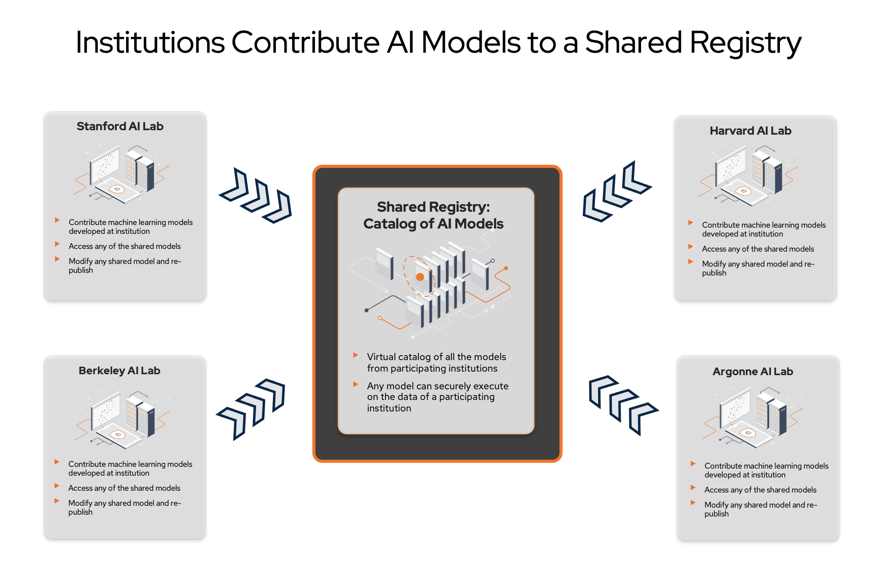

Illustration 1 - Shared Registry with decentralized data

The basic premise is that the various institutions and individuals will use a shared registry of common AI models. This registry becomes a catalog of models, with different versions trained for specific purposes. These models can be transferred, then used and reused in each edge location, running on-premise data to tune these collectively pre-trained models. Both bespoke and general core models will exist in the shared registry, available to be shared across locations without moving the resident data. Retention of training based on the individual locations will be regulated as per the access/authentication controls and the intent of the original data producer, thus maintaining the desired security paradigm and privacy controls.
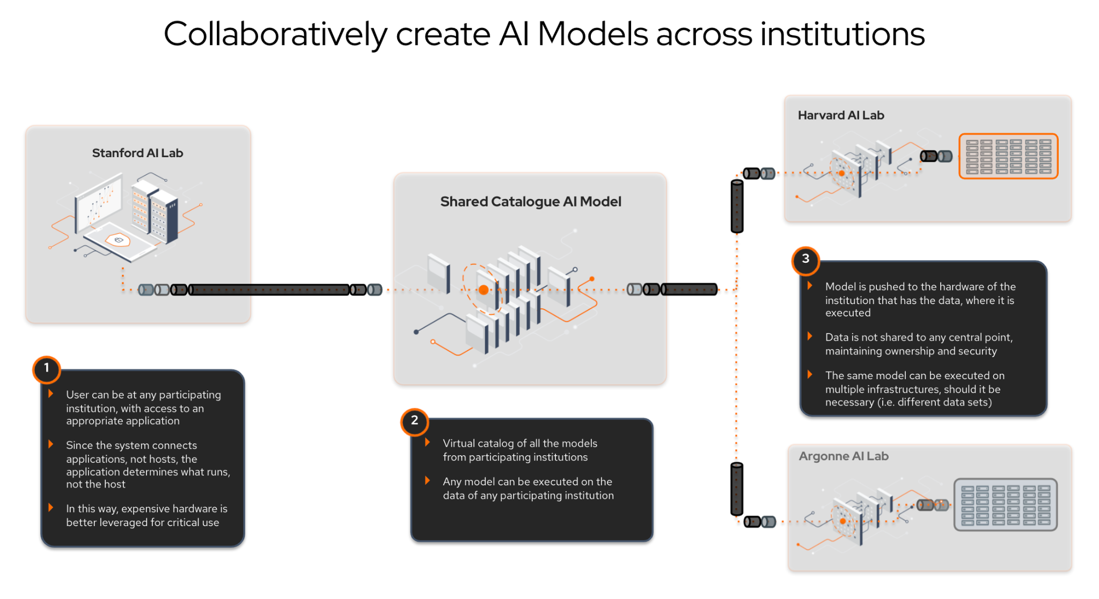

Illustration 2 - Secure Collaboration Diagram

The shared infrastructure enables users at one institution to access models at another institution and execute those models on data of any participating institution. In this way, users are not limited to only running models at their institution or data gathered only at their institution. Further, the utility of models is greatly enhanced because they can be used against many different data sets. A true shared model is created.

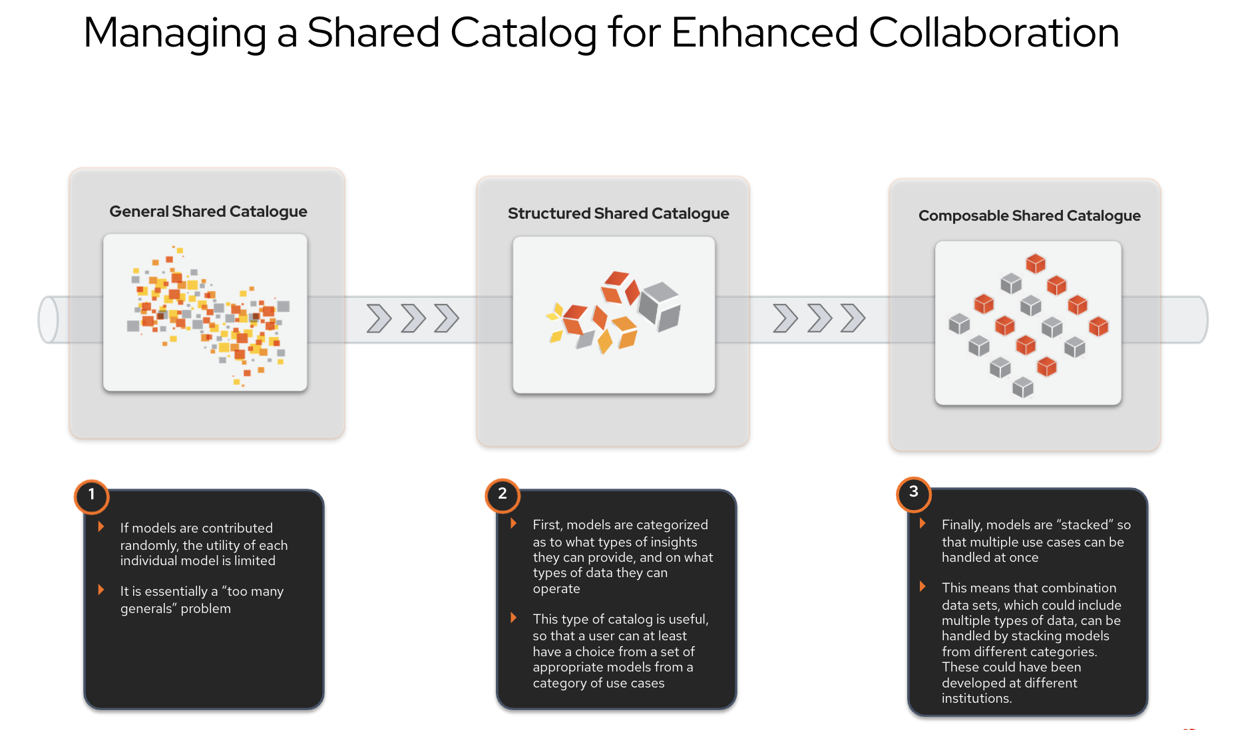Illustration 3 - Managing the shared repository/catalog

Since models are dependent on the types of data they act upon, it’s crucial to organize models by the kinds of data they can process. Once completed, the models can be “stacked” so a stack of 2 appropriate models can execute that data composed of two other types of data. This is the essence of the “composable shared catalog.”

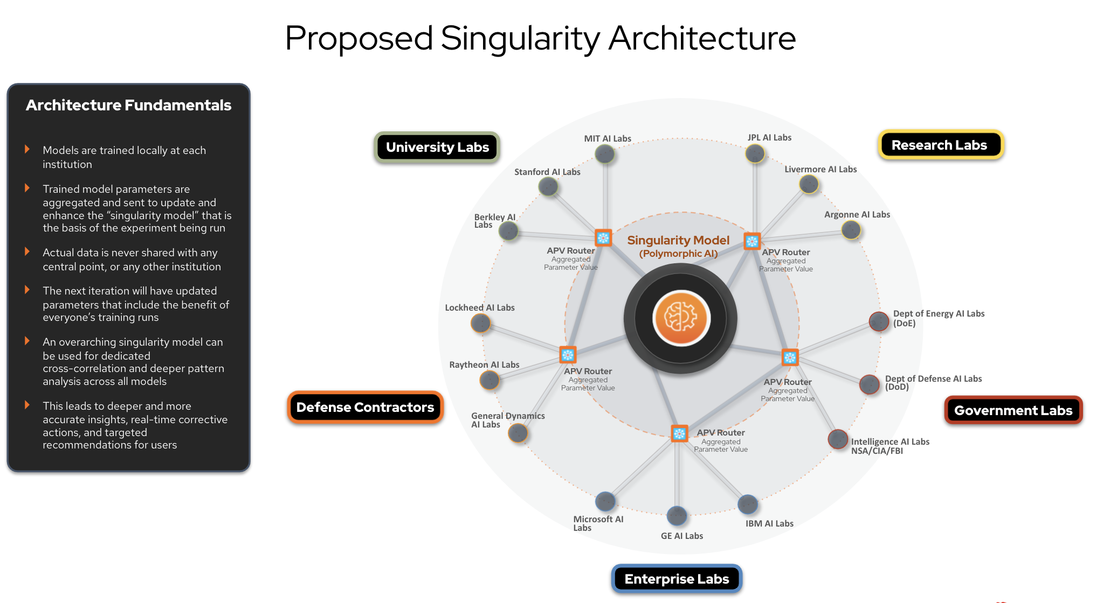Illustration 4 - Tiered Cross-correlation Framework

For this framework, singularity refers to the greatest synergy between human and artificial intelligence. It is humanity’s greatest ally in the realm of scientific discovery, industrial advances, and the fight against environmental threats. A central cross-correlation engine that conducts ongoing pattern analysis, security reviews, and bias health checks will cross all the activities within the various resources. It is an opt-in model, and not every classified lab function will require (or be given) access to this resource. But in the case of the national labs, a real-time cross-correlation function can advance science with deeper insights and course correction during experimental campaigns. The complete body of lab research then becomes a national AI resource. The enterprise and AI startups can help propel their intellectual property forward with new feature discovery, digital twin testing, and rapid time to market.

One primary intelligence can analyze all incoming and historical data, or it can be a series of singularities that are purpose-built for different fields of endeavor. In any event, having this capability gives a far more profound understanding of our environment and all its possibilities.
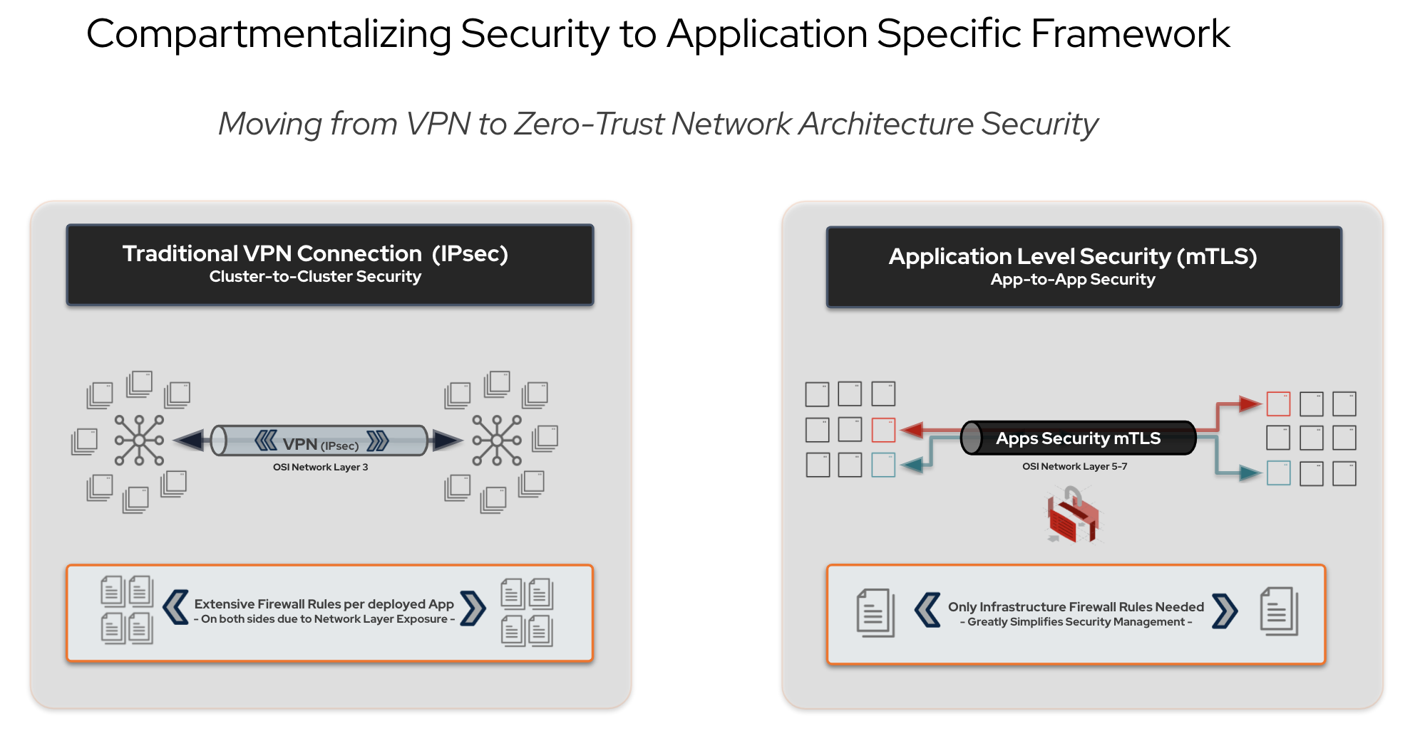

Illustration 5 - Application Specific Framework with Security Isolation

Since we are using a shared infrastructure model, data security must be handled more granularly than in traditional approaches. It is not sufficient to have a “single access point” that grants access to all models and all data – such a system would be vulnerable to a single security breach giving access to everything (as is shown in the traditional architecture on the left).

On the right side of the diagram, the more modern approach shows how individual application access controls can be applied so that having access to one application does not give access to all resources. These can even be timed and/or revocable access tokens. A single security breach would not result in more than one application being compromised.

An Open Source Community Approach to National AI Infrastructure and Research

In terms of all RFI elements, it seems clear that an open community approach to the ownership and maintenance of this resource would be optimal. Essentially, a federated compute, storage, and AI development environment composed of multiple labs and data centers, connected on a highly secure and lossless framework, with a small group of dedicated paid resources to manage the common infrastructure instance. This funded management team would coordinate architectural upgrades and responses to technical issues.

The related hardware and software resources would be donated and shared by the various organizations and participants in a federated network architecture. A governance model for this resource could be based on open community principles via the Linux Foundation or similar community frameworks. Furthermore, given element D, it requires a multi-tiered approach to data access and provenance tracking through Distributed ledger-based technology. All domains will likely benefit significantly from HPC-enabled digital twin simulaiton and modeling. This motivates an infrastructure that enables a unified framework among a diversity of components, from the IoT Edge to the HPC Core. Such heterogeneity will be critical to the success of this endeavor, and several platforms and emerging techniques can be combined to help address this requirement.

Commonly known required components:
- Open and closed data sets that help participants enable model training capability to be identified, built, and curated. Metadata frameworks would be created to increase efficiency and help navigate issues of privacy and bias.
- A generalized digital twin environment that supports discovery and data set generation.
- A user-permission and authentication mechanism.
- A platform to create, distribute and manage AI models, with capabilities including ground-up development, pre-built models, pipeline workflow, lifecycle management, and drift correction.
- A hardware environment including all necessary resources, including storage, processors (GPU/TPU/IPU, x86, ARM), networking components, and software infrastructure platforms (Kubernetes, container management, databases, memory optimization, etc.).

Unique elements would include:
- A flexible and dynamic resource federation model that is based on an automated data fabric that extends across all elements. This helps private sector firms gain access to and directly build better hardware and software via a shared space that is co-designed with public sector emerging needs.
- A marketplace that enables both open and private science and industry, with models available to any organization. In essence, a library of templated architectures and base pre-trained AI models for related research purposes that ultimately enable cross-correlation of models, incorporating relevant heterogeneous data sources and sensors that can generate pattern analysis in real-time to enable deeper insights and rapid course correction.
- A library of composable transformation and featurization layers that aid user adoption of the templated architectures and enable security and provenance tracking from the beginning of the development cycle.
- A software-defined memory allocation and virtualization framework that eliminates bottlenecks for large-scale AI workloads and optimally capitalizes on both on-premise and distributed data stores.
- A tiered security architecture that includes:
  - Ongoing 24/7 penetration testing with non-intrusive security scans.
  - Distributed ledger-based user/resource authentication.
  - Layer 7 integration strategy (intrusions relegated to a single application).
  - Biometric authentication and resource isolation within the federated network for sensitive workstreams.
  - Monitor decryption keys for data provenance, audit, and automated discovery of abuse patterns.
  - Independent software instances that autonomously assign themselves to assess and scan newly federated hardware.
- Open source fairness and bias management tools, provided by a dedicated community ethics group. This team will apply operational parameters to data sources, metadata layers, and cross-correlation engines to maintain systemic neutrality. This includes a tight focus on privacy and the protection of individual rights.

Capabilities and services for prioritization

- Curated and openly available data sets and the respective model templates would be the top priority in our estimation.
- Various users and institutions can access openly available models in a registry that matches suggested models and templates based on the user example data.
- Readily available hardware infrastructure for model training, openly available to all member institutions. Beyond training requirements, the use of more expensive chipsets (GPUs, TPUs, IPUs, FPGAs, etc.) should be evaluated from a price/performance perspective against standard chip architectures (x86, etc.) in terms of production lab use. This will lead to a balanced workload approach, cost savings, and co-designed hardware and algorithm compositions as well as encourage community exploration of emerging new technology.

Ethical and responsible research and development of AI - racial and gender equity, fairness, bias, civil rights, transparency, and accountability

Current building blocks and resources

The various national lab environments (Argonne, Oak Ridge, Stanford SLAC, etc.) can be unified as a federated infrastructure, using containerized technologies and integration via container platform and data fabric/layer 7 application networks. With a metadata engine and digital twin layer, the proposed federated approach would enable secured data to remain on-premises but would allow each of the partner labs to leverage the computing resources across the DOE complex.

Public-private partnerships

Community-based research organizations like the Enterprise Neurosystem serve as examples of grass-roots efforts that act as a crossroads between academia, government, and the private sector, with a common goal of creating global scale infrastructure for humanity and the environment. The high level of private interest in such an organization shows the appetite for participation in a fair and federally regulated AI infrastructure. By launching from the paradigm of open sourceBy encouraging partnerships between industries, academia, and government, the resulting ecosystem provides an open arena for encouraging equitable access, early experience with developing technologies, and diverse insight into the strengths and weaknesses of participant approaches that ultimately yields a more robust AI infrastructure and industry.
sin collaboration with our partners in a academia and the federal research labs. .

With common overarching objectives, a multi-tiered project approach has been robust and proven in practice. Members and the private sector both support and contribute to the Enterprise Neurosystem proof of concept. The membership of the community provides the related infrastructure as an open-source and shared approach to hardware infrastructure, with set permissions for users mapped to projects. We have security development tracks, application layer connectivity, and a distributed ledger authentication end state. And the ethical guideline development track is a fascinating exercise in canvassing operational philosophies and multicultural guidelines to create an intelligence that will non-intrusively contribute to society in a positive and unbiased manner. As we have a lab and private sector participation with shared hardware and open and available data sets, this navigation has been pain-free to date.

There is strong support for academic, government, and industry projects within this community, and these activities allow the private sector to find benefits through federal research and vice versa. For example, creating a similar neurosystem for the Fortune 500 would support a Business Singularity for each corporation. A real-time intelligence that helps each corporation would be an evolutionary step in AI development that spans both AIOps and Business Intelligence functionality; creating mutual benefit for all parties is a primary objective.

Democratic access to AI R&D

Data sensitivity to sharing across organizations is a significant challenge for a national AI infrastructure. Federated Machine Learning and confidential computing best practices will certainly help address the challenge by maintaining the integrity of individual data silos and adding the abstraction layers of Federation and metadata generation to provide accurate results without compromising privacy or security.

------------

- Bias sniffer - walks through models and data - looking for nefarious items of undue and accidental bias
- Singularity architecture
- D = Operate First
- Roaming security sniffers
- Private cross-agency multi-cloud architecture
- E = Neurosystem
- DoE: Pay for and manage public preemptible hardware and data sets - peoples jobs should have an independent trusted arbiter for deciding US value of data and compute jobs re resource usage credits.
- G = Singularity slide
- Enable open AI x-labs without being subsumed by eg Microsoft. Keep them independent of large corporate interests in the private sector.
- F = HDAG / Harvard internship
- Use training platform to proselytize DoE-vetted Ethical AI

RFI Response - Proposed improvements to the OSTP National Research and Development AI Plan.
(A) Determine and prioritize areas of artificial intelligence research, development, and demonstration requiring Federal Government leadership and investment;

- Areas of investment should begin with open training data sets, and model libraries for research use.
- Creation of a self-identifying digital resource/model platform as an operational foundation, spanning all related clouds/data centers with a container management system and memory virtualization (ex. Kove)..
- Second wave of development to include small to large-scale cross-correlation engines, to search for deeper patterns across targeted models and data in research programs.
- Bias/ethical governance applied at the kernel level to these cross-correlation models.
- Investment and wide availability of advanced AI hardware and software resources (Cerebras, GraphCore, Intel, Kove, etc.) for a highly optimized research environment.
- Enable preemptable public use of LCF (SUMMIT/ALCF AI testbed).

(C) Support research and other activities on ethical, legal, environmental, safety, security, bias, and other appropriate societal issues related to artificial intelligence;

In the Enterprise Neurosystem community, there is a study group track dedicated to potential ethical and safety issues in using AI technologies that influence or govern humanity. The community also recognizes the underlying societal and cultural bias in data, affecting even the most granular AI determinations. Advanced feature engineering techniques will be explored to manage preference and develop ancillary AI models to assist the core intelligence and overall system in driving greater accuracy. And once complete, this ethical guidance system must not be a bolt-on option but shall reside at the kernel level within the primary guidance model to maintain beneficial outcomes for humanity.

- Model and data metrics that include alignment with "intent" of model and data producers.
- Bias sniffer to search for accidental and nefarious actors.
- Develop roaming AI programs that act as independent “T-Cells,” mapping to biological models that seek out and cleanse malware from the AI production environment.
- New networking techniques that securely connect AI models at the application level, reducing security intrusions to a single model or application.

(D) provide or facilitate the availability of curated, standardized, secure, representative, aggregate, and privacy-protected data sets for artificial intelligence research and development;

Open and closed data sets are required that will help participants enable model training capability to be identified, built, and curated. Metadata frameworks should be created to increase efficiency and help navigate issues of privacy and bias.

- A generalized digital twin environment that supports discovery and data set generation.
- A user-permission and authentication mechanism.
- Public proof of concept (Hello World) versions of privacy-preserving federated ML across private cross-agency multi-clouds.

(E) provide or facilitate the necessary computing, networking, and data facilities for artificial intelligence research and development;

In terms of all RFI elements, it seems clear that an open community approach to the ownership and maintenance of this resource would be optimal. Essentially, a federated compute, storage, and AI development environment composed of multiple labs and data centers is connected on a highly secure and lossless framework, with a small group of dedicated paid resources to manage the common infrastructure instance. This funded management team would coordinate architectural upgrades and responses to technical issues.

The related hardware and software resources would be donated and shared by the various organizations and participants in a federated network architecture. A governance model for this resource could be based on open community principles via the Linux Foundation or similar community frameworks. Furthermore, it requires a multi-tiered approach to data access and provenance tracking through Distributed ledger-based technology.

All domains will likely benefit significantly from HPC-enabled metadata and digital twin creation. This motivates an infrastructure that enables a unified framework among a diversity of components, from the IoT Edge to the HPC Core. Such heterogeneity will be critical to the success of this endeavor, and several platforms and emerging techniques can be combined to help address this requirement.

Commonly known required components:
- Open and closed data sets that help participants enable model training capability to be identified, built, and curated. Metadata frameworks would be created to increase efficiency and help navigate issues of privacy and bias.
- A generalized digital twin environment that supports discovery and data set generation.
- A user-permission and authentication mechanism.
- A platform to create, distribute and manage AI models, with capabilities including ground-up development, pre-built models, pipeline workflow, lifecycle management, and drift correction.
- A hardware environment including all necessary resources, including storage, processors (GPU/TPU/IPU, x86, ARM), networking components, and software infrastructure platforms (Kubernetes, container management, databases, memory optimization, etc.).

Unique elements would include:
- A flexible and dynamic resource federation model that is based on an automated data fabric that extends across all elements. This helps private sector firms gain access to and directly build better hardware and software via a shared space that is co-designed with public sector emerging needs.
- A marketplace that enables both open and private science and industry, with models available to any organization. In essence, a library of templated architectures and base pre-trained AI models for related research purposes that ultimately enable cross-correlation of models, incorporating relevant heterogeneous data sources and sensors that can generate pattern analysis in real-time to enable deeper insights and rapid course correction.
- A library of composable transformation and featurization layers that aid user adoption of the templated architectures and enable security and provenance tracking from the beginning of the development cycle.
- A software-defined memory allocation and virtualization framework that eliminates bottlenecks for large-scale AI workloads and optimally capitalizes on both on-premise and distributed data stores.
- A tiered security architecture that includes:
  - Ongoing 24/7 penetration testing with non-intrusive security scans.
  - Distributed ledger-based user/resource authentication.
  - Layer 7 integration strategy (intrusions relegated to a single application).
  - Biometric authentication and resource isolation within the federated network for sensitive workstreams.
  - Monitor decryption keys for data provenance, audit, and automated discovery of abuse patterns.
  - Independent software instances that autonomously assign themselves to assess and scan newly federated hardware.
- Open source fairness and bias management tools, provided by a dedicated community ethics group. This team will apply operational parameters to data sources, metadata layers, and cross-correlation engines to maintain systemic neutrality. This includes a tight focus on privacy and the protection of individual rights.
- Have an independent (trusted) arbiter to decide US value of e.g. data and compute jobs, that determine resource usage credits, to have the job control, routing and preempting decisions.

(F) support and coordinate Federal education and workforce training activities related to artificial intelligence; and

Use open source AI research organizations (Enterprise Neurosystem, etc.) to act as a collaborative bridge between the academic world, government and private sector organizations. In this example, the community brought students at Harvard Analytics together with Stanford SLAC in an educational exercise, building transformer models similar to those actually used in the Stanford SLAC/LCLS production use case. Also consider:

- Internship programs that use DOE problems as open testbeds for educational (hello world) training.
- Use this platform to proselytize (DOE-vetted) ethical AI, and encourage ethical standardization implementation handles via template adoption in training efforts.

(G) support and coordinate the network of artificial intelligence research institutes.

- Enable OpenAI-like x-labs that are viable without needing to get subsumed in e.g Microsoft, keep them independent of large corporate interests but still private sector-minded.
- Deploy wide-frame container architectures and AI model self-identifying frameworks across the multiple research institutes and labs, for resource sharing and cohesion.

Contributing Authors and Review Committee:
Ryan Coffee
Senior Staff Scientist
SLAC National Accelerator Laboratory

Ben Cushing
Federal Health and Science Lead
Red Hat Inc.

Erik Erlandson
Senior Principal Software Engineer
Red Hat Inc.

Ganesh Harinath
CEO
Fiducia | AI

Vishnu Hari Kumar
Product Manager
Meta AI
Pierre Mathys
Global Senior Director, Telco Edge Solutions
Red Hat, Inc.

John Overton
CEO
Kove

Audrey Reznik
Senior Software Engineer
Red Hat Inc.

Dinesh Verma
CTO, Edge Computing and IBM Fellow
IBM Research

Bill Wright
Head of AI/ML and Intelligent Edge
Industries and Global Accounts
Red Hat, Inc.

